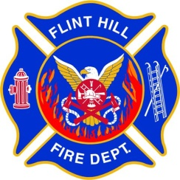 | FLINT HILL FIRE DEPARTMENT  STANDARD OPERATING GUIDELINE

Guideline Number: 402.03
Guideline Title: Rehabilitation
Adopted: 02/12/2024
Rescinds: New

Approved By: (Chief)

- PURPOSE:

To provide guidance on the implementation and use of a rehabilitation process as a requirement of the Incident Management System (IMS) at the scene of a fire, other emergency, or training exercise. It will ensure that personnel who might be suffering the effects of metabolic heat buildup, dehydration, physical exertion, and/or extreme weather receive evaluation and rehabilitation during emergency operations.

- DISCUSSION:

There is great evidence nationwide supporting the fact that far more firefighters die from heart attack and heat exhaustion related injuries than from trauma. Because of that, this Standard Operating Guideline will cover all staff, relating to rehabilitation at emergency scenes and training events to ensure that our personnel stay safe and properly rested and hydrated.

- RESPONSIBILITIES:

- The Incident Commander (IC) should consider the circumstances of each incident or training evolution and make adequate provisions early in the incident for the rest and rehabilitation for all members operating at the scene. These provisions may include medical evaluation, treatment and monitoring, food and fluid replenishment, mental rest and relief from extreme climatic conditions and other environmental parameters of the incident. The rehabilitation should include the provision of Emergency Medical Services (EMS) at the Basic Life Support (BLS) level or higher.

- All officers should maintain an awareness of the condition of each member operating within their span of control and ensure the adequate steps are taken to provide for each members safety and health. The command structure should be utilized to request the reassignment of fatigued crews.

- During periods of hot weather, members should be encouraged to drink water or other hydrating beverages throughout the incident. During any emergency incident or training evolution, all members should advise the officers when they believe that their level of fatigue or exposure to heat or cold is approaching a level that could affect themselves, their crew, or the operation in which they are involved. Members should also remain aware of the health and safety of other members of their crew.

- ESTABLISHMENT OF REHABILITATION GROUP:

- The IC may establish a Rehab Area with a Rehab Group Supervisor when conditions indicate that rest and rehabilitation is needed for personnel operating at an incident scene or training evolution.

- A member from EMS will be placed in charge of the Rehab Area and may be known as the Rehab Group Supervisor. If no member is available from EMS, the IC should designate an EMT to be the Rehab Group Supervisor. The individual designated as the Rehab Group Supervisor will report directly to the IC. Additional Units may be requested through the IC depending on the amount of medical care required in the Rehab Group.

- The location for the Rehab Area will normally be designated by the IC. If a specific location has not been designated, the Rehab Group Supervisor should select an appropriate location based on the site characteristics and designations below:
  - It should be in a location that will provide physical rest by allowing the body to recuperate from the demands and hazards of the emergency operation or training evolution.
  - It should be far enough away from the scene that members may safely remove their turnout clothing and SCBA and be afforded mental rest from the stress and pressure of the emergency operation or training evolution.
  - It should provide suitable protection from the prevailing environmental conditions. During hot weather, it should be in a cool, shaded area. During cold weather it should be in a warm, dry area.
  - It should enable members to be free from exhaust fumes from the apparatus or equipment (including those involved in the rehab sector/group operations).
  - It should be large enough to accommodate multiple crews, based on the size of the incident.
  - It should be easily accessible by EMS units.
  - It should allow prompt re-entry back into the emergency operation upon complete recuperation.

- Site designation suggestions:
  - A nearby garage, building lobby, or other structure.
  - A school bus.
  - Fire apparatus, ambulance, or other emergency vehicles at the scene or called to the scene.
  - An open area in which a rehab area can be created using tarps, fans, etc.

- Resources - The Rehab Group Supervisor should secure all necessary resources required to adequately staff and supply the Rehab Area. The supplies may include the items listed below:
  - Fluids -water, activity beverage, oral electrolyte solutions and ice.
  - Food -soup, broth, or stew in hot/ cold cups.
  - Medical -blood pressure cuffs, stethoscopes, oxygen administration devices, cardiac monitors, intravenous solutions, and thermometers.
  - Other -awnings, fans, tarps, smoke ejectors, heaters, dry clothing, extra equipment, floodlights, blankets and towels, traffic cones and fire line tape (to identify the entrance and exit of the Rehab Area).

- GUIDELINES:

- Rehabilitation Area / Group Establishment:
  - Staff officers, during the initial planning stages of an emergency response or training evolution, should consider rehabilitation. However, the climatic or environmental conditions of the emergency scene should not be the sole justification for establishing a Rehab Area. Any activity/incident that is large in size, long in duration, and/or labor intensive will rapidly deplete the energy and strength of personnel and therefore merits consideration for rehabilitation. Climatic or environmental conditions that indicate the need to establish a Rehab Area are a heat stress index above 90 F (see table 1-1) or Wind chill index below 10F (see table 1-2).

- Hydration:
  - A critical factor in the prevention of heat injury is the maintenance of water and electrolytes. Water must be replaced during emergency incidents and training evolutions. During heat stress, the member should consume at least one quart of water per hour. Rehydration is important even during cold weather operations where, despite the outside temperature, heat stress may occur during firefighting or other strenuous activity when protective equipment is worn. Caffeine beverages should be avoided before and during heat stress because both interfere with the body’s water conservation mechanisms. Carbonated beverages should also be avoided.

- Nourishment:
  - The department should provide food at the scene of an extended incident when units are engaged for three or more hours. A cup of soup, broth, or stew is highly recommended because it is digested much faster than sandwiches and fast-food products. In addition, foods such as apples, oranges, and bananas provide supplemental forms of energy replacement. Fatty and/or salty foods should be avoided.

- Rest:
  - The “two air bottle rule”, is recommended as an acceptable level prior to mandatory rehabilitation. Members should rehydrate (at least eight ounces) while SCBA cylinders are being changed. All members should be sent to the Rehab Area following the use of two 30-minute or 45-minute SCBA cylinders or one 60-minute SCBA cylinder. Shorter times might be considered during extreme environmental condition. In all cases, the objective evaluation of a members fatigue level shall be the criteria for rehab time. Rest should not be less than 10 minutes and may exceed an hour as determined by the Rehab Group Supervisor. Fresh crews released from the Rehab Area, should be available in the staging area to ensure that fatigued members are not required to return to duty before they are rested, evaluated, and released by Rehab Group Supervisor.

- Recovery:
  - Members in the Rehab Area should maintain a high level of hydration. Members should not be moved from a hot environment directly into an air-conditioned area because the body’s cooling system could shut down in response to the external cooling. An air-conditioned environment is acceptable after a cool-down period at ambient temperature with sufficient air movement. Certain drugs impair the body’s ability to sweat and extreme caution must be exercised if the member has stimulants.

- Medical Evaluation:
  - EMS should be provided and staffed by the most highly trained and qualified EMS personnel on the scene (at a minimum of BLS level). They may evaluate vital signs, examine members, and make proper disposition (return to duty, continued rehabilitation, or medical treatment and or transport to medical facility), based off of the NFPA 1584 Fire Rehabilitation Protocol flowchart, provided below. Continued rehabilitation should consist of additional monitoring of vital signs, providing rest, and providing fluids for rehydration. Medical treatment for members, whose signs and/or symptoms indicate potential problems, should be provided in accordance with local medical control procedures. EMS personnel should be assertive to find potential medical problems early.
  - The Rehab Group Supervisor will inform IC, as soon as practical, if there are any firefighters that need to be transported from the scene.
  - If an ambulance transports a patient from the scene, the IC may bring in another ambulance to be on stand-by from the scene.
  - Documentation - All medical evaluations should be recorded along with the members name and complaints, and must be signed, dated, and timed by the Rehab Group Supervisor or designee.

- Accountability - Members assigned to the Rehab Group should enter and exit the Rehab Area as a crew. The crew designation, number of crew members, and the times of entry to and exit from the Rehab Area should be documented by the Rehab Group Supervisor or his/ her designee. Crews should not leave the Rehab Area until authorized to do so by the Rehab Group Supervisor.

HEAT STRESS INDEX
(Table 1-1)

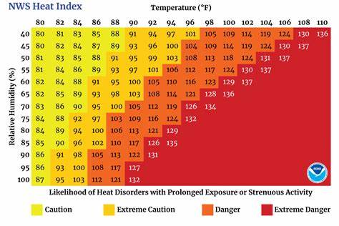
Note: Add 10° F when protective clothing is worn and add 10° F when in direct sunlight.

HUMITURE °F DANGER CATEGORY INJURY THREAT:
- Below 60° - None, little or no danger under normal circumstances.
- 80°-90° - Caution: Fatigue possible if exposure is prolonged and there is physical activity.
- 90°-105° - Extreme Caution: Heat cramps and heat exhaustion possible if exposure is prolonged and there is physical activity.
- 105°-130° - Danger: Heat cramps or exhaustions likely. Heat stroke possible if exposure is prolonged and there is physical activity.
- Above 130° - Extreme Danger: Heat stroke imminent!

WIND CHILL INDEX
(Table 1-2)

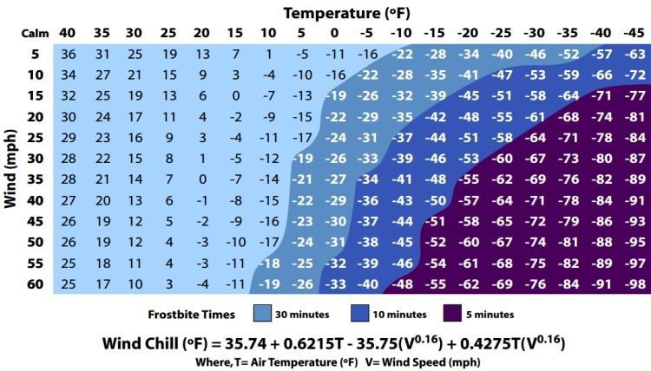

WIND CHILL TEMPERATURE °F DANGER
- -25° F to -75° F – Increasing danger, flesh may freeze
- Below -75° F – Great danger, flesh may freeze within 30 seconds.

