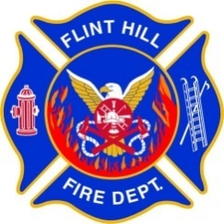 | FLINT HILL FIRE DEPARTMENT  STANDARD OPERATING PROCEDURE

Procedure Number: 111.04
Procedure Title: Nominated Award Voting
Adopted: 02/01/2023
Rescinds: 03/03/2015

Approved By: (Chief)

- PURPOSE:

This SOP defines the voting process for selecting nominated award recipients of the Flint Hill Fire Department (FHFD).

- DISCUSSION:

Annually the membership of the FHFD recognizes members of the department who have excelled in their service to the department through nominated awards. This SOP defines the selection process for nominated awards. See POLICY 110.01 AWARDS for a description and eligibility for the nominated awards.

- PROCEDURE:

- The selection of nominated award recipients is conducted annually at the beginning of each calendar year, typically in January, for the previous calendar year. Each year the timing is determined by the date of the awards banquet (typically in March).

- Nominations must be written and include the nominated members name, award nominated for, and a short justification (4 – 6 sentences recommended) of why the member should receive the award.

- Each year the Deputy Chief of Administration (DCA) will announce a 10-day nomination period via email during which nominations will be accepted.
  - Nominations must be emailed to the DCA and received by the specified due date/time.

- After the nomination due date has passed the DCA shall compile the nominations and distribute an online voting survey in a timely manner with the nominations organized by award.
  - For a nomination to be included, the nominated member must be eligible for the award and be in good standing.
  - All active members on the department roster at the time of the vote receive the survey.
  - Members can vote for one or no nominee for each award.
  - Voting is open for 10 days before the survey closes after which the results are submitted to the Fire Chief and the awards ordered.
  - The survey software prevents multiple voting by members, but members remain anonymous even to the survey administrators.

- In the case of ties between the top vote getters all nominees receive the award.

