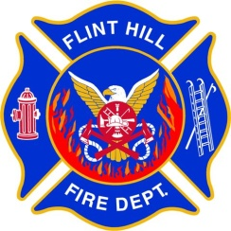 | FLINT HILL FIRE DEPARTMENT  GENERAL POLICY

Policy Number: 110.02
Policy Title: Flower Fund
Adopted: 10/04/2023
Rescinds: 04/08/2021

Approved By: (Chief)

- PURPOSE:

This policy establishes guidelines for purchasing flowers and fruit baskets using 1% funds for the sick, injured, or bereaved for Flint Hill Fire Department (FHFD) members and their immediate family.

- DISCUSSION:

All members of FHFD and their immediate family members as defined herein are eligible to receive flowers or fruit baskets during times of serious illness/injury, or bereavement as specified in this policy. Any other use of the FHFD Flower fund is prohibited, including cash donations in lieu of flowers or any other cash distribution.

- POLICY:

SERIOUS ILLNESS/INJURY

- Eligible individuals are as follows:
  - Member
  - Spouse
  - Child
  - Parent
- Eligible individuals may receive flowers or a fruit basket when treated for a serious illness or injury that requires overnight hospitalization. The intent is to respond to serious illnesses or injuries, not routine medical visits, or common illnesses.
- The maximum amount per expenditure shall not exceed $125 (including delivery, taxes, etc.).

BEREAVEMENT

- Eligible individuals are as follows:
  - Member
  - Spouse
- Eligible individuals may receive flowers or a fruit basket upon the death of one of the following:
  - Member
  - Spouse
  - Child
  - Sibling
  - Parent
  - Grandparent
- The maximum amount per expenditure shall not exceed $175 (including delivery, taxes, etc.).

